Details of experiment

**Wind tunnel**

The Kestrel will be mounted in the blue wind tunnel at the RMIT Bundoora Campus. It is a closed return wind tunnel [11]. The wind tunnel is built across two floors with wind generated by a fan on the first floor sent to the second floor where the testing area is. This design ensures steady delivery of laminar flow, wind flow without disturbances. Figure 2 from displays this generic design. The vanes on each corner of the tunnel ensure that the flow is laminar.

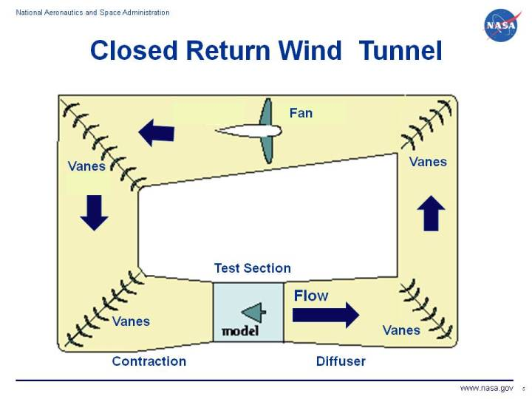

**Figure 2: Closed return wind tunnel design [10]**

A pressure probe embedded in the test area allows us to assess the pressure in the wind tunnel. Knowing the target speed and the ambient temperature and air pressure of the wind tunnel allows us to calculate a target pressure which is what we aim for when testing. All our testing occurred at approximately 0.0155 kPa or 5 m/s, the target pressure would fluctuate throughout the day as ambient temperature and pressures changed. As such we regularly calculated the target pressure to ensure consistent speeds.

**Load cell**

The Kestrel is mounted directly onto a 30 N load cell (Figure 3). The output from the load cell describes the major forces occurring on the Kestrel. After processing through the data acquisition box, we are given a list of 6 values: the force in N at X, Y and Z. We are also given moments in X, Y and Z, which is expressed in Nm. The primary force used in training and testing was the force at Y or the lift.

**Figure 3: 30 N load cell**

Before each test the load cell must be calibrated to ensure we return accurate results. In our design we take 1000 results from the load cell and store the average for each measure in a file. This average is then subtracted from each test measurement to zero the load cell. We recognised some drift in the load cell and therefor we calibrated the load cell regularly.

**Data output**

After a test everything that happens at each timestep this includes all the forces in N and moments in Nm, the new set position of each servo as decided by the controller and the error lift. For all tests the lift of the bird was targeted to be 0.42 N.

This data will be sufficient to capture our primary outcomes:

* Time taken to stabilise the bird
* Quality of transition to stability
* Quality of stability (error is as close to zero as possible throughout flight)

In addition to assessing the robustness of our controllers the output will allow us to compare to the pre-trained DRL model.

The following is the experimental workflow that was carried out to conduct each major test.

1. Load cell calibration, to zero the load cell
2. Dynamic pressure assessment, to ensure consistent speeds
3. Set wind speed, based on dynamic pressure assessment
4. Run test of interest PID / MPC / SVR tuner
5. Data collection

[11] [Closed Return Wind Tunnel (nasa.gov)](https://www.grc.nasa.gov/www/k-12/airplane/tuncret.html)